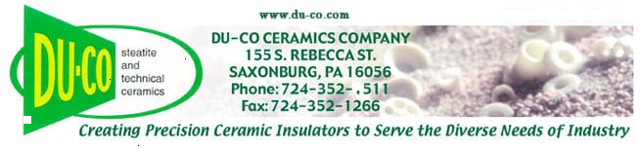
Date: July 30, 2026

Du-Co Ceramics Company
155 S. Rebecca Street
PO Box 568
Saxonburg, PA 16056

Subject: TSCA Restricted Substances Declaration

The United States Toxic Substances Control Act (TSCA) is a federal chemicals management regulation. Under TSCA Section 6, certain substances and substance families (including treated articles containing these substances) are restricted from distribution in U.S. commerce, including:
- Asbestos
- Lead, when used in paint
- Polychlorinated biphenyls (PCBs)
- Dioxins
- Chlorofluorocarbons (CFCs, ozone depleting substances)
- Metallic mercury, when used in consumer products
- Formaldehyde, when used in composite wood products
- Nitrites, when used in certain cutting fluids
- Hexavalent chromium compounds, when used in water treatment
- Five Persistent, Bioaccumulative, and Toxic substances restricted in 2021:
  - PIP 3:1 (CAS 68937-41-7)
  - DecaBDE (CAS 1163-19-5)
  - 2,4,6 TTBP (CAS 732-26-3)
  - HCBD (CAS 87-68-3)
  - PCTP (CAS 133-49-3)
- Substances added to TSCA Section 6(1) in December 2024:
- TCE (Trichloroethylene)
- PCE (Perchloroethylene)
- CTC (Carbon Tetrachloride)

Du-Co Ceramics Company certifies that none of our products contain any substances currently restricted under TSCA.

Sincerely,
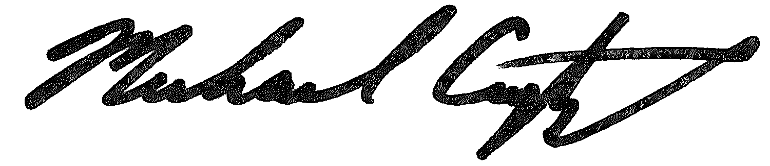
Michael Crytzer
VP Operations

