
Date: July 30, 2026

Du-Co Ceramics Company
155 S. Rebecca Street
PO Box 568
Saxonburg, PA 16056

Subject: RoHS 3 Directive 2011/65/EU – amendment (EU) 2015/863 – Non-Metalized Ceramics
China RoHS 2 requirements, dated July 1, 2016. – Non-Metalized Ceramics
EU Batteries Directive (2006/66/EC), EU Packaging and Packaging Waste Directive (94/62/EC)
Per- and Polyfluoroalkyl Substances (PFAS) Statement
Annex XVII of COUNCIL REGULATION (EU) No 833/2014
United States Executive Order 14068 / Canadian SOR/2014-58

- As per RoHS 3 Directive 2011/65/EU – amendment (EU) 2015/863 and China RoHS 2 requirements, dated July 1, 2016 (Management Methods for the Restriction of the Use of Hazardous Substances in Electrical and Electronic Products), Du-Co Ceramics Company does not process and/or supply any products that contain the following substances in excess of the allowable limits:

Lead (< 1000 ppm) | Mercury (<100 ppm) | Cadmium (<100 ppm)
Hexavalent Chromium (< 100 ppm) | Benzyl butyl phthalate (BBP): < 1000 ppm | Diisobutyl phthalate (DIBP): < 1000 ppm
Bis(2-Ethylhexyl) phthalate (DEHP) (< 1000 ppm) | Polybrominated Biphenyls (PBB) (< 1000 ppm) | Polybrominated Diphenyl Ethers (PBDE) (< 1000 ppm)
Dibutyl phthalate (DBP): < 1000 ppm

- Du-Co Ceramics Company does not produce any battery or accumulator containing products, so the EU Batteries Directive (2006/66/EC) does not apply.
- All packaging used by Du-Co Ceramics Company, to the best of our knowledge, complies with the EU Packaging and Packaging Waste Directive (94/62/EC).
- Du-Co uses no flame retardants in the manufacture of our products.
- Du-Co does not supply any products that contain Per- and Polyfluoroalkyl Substances, also known as PFAS.
- Du-Co hereby declares that our products are Halogen-free products. The Definition on Halogen-free products is based in industry standard IEC(International Electrotechnical Commission) - Finalized Requirements of IEC 61249-2-21
- Du-Co products do not contain any Iron and Steel so prohibitions set forth in the Annex XVII of COUNCIL REGULATION (EU) No 833/2014 regarding Iron and Steel do not apply.
- Du-Co products do not contain any Aluminum, Copper, or Nickel, so prohibitions set forth under United States Executive Order 14068 or Canadian SOR/2014-58 regarding these materials do not apply.
- Du-Co Products do not contain Dechlorane Plus or UV-328.

Metalized Ceramics are NOT RoHS 3 or China RoHS 2 compliant as they contain Lead.

Sincerely,
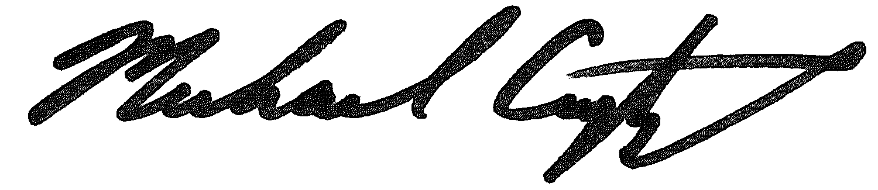
Michael Crytzer
VP Operations

